University of Wolverhampton
School of Mathematics and Computer Science
Student Number:2407710
Name: Dhadkan K.C.
6CS005 High Performance Computing Week 1 Workshop
Revision on C and Multithreading
Tasks – Basic C Syntax
1
1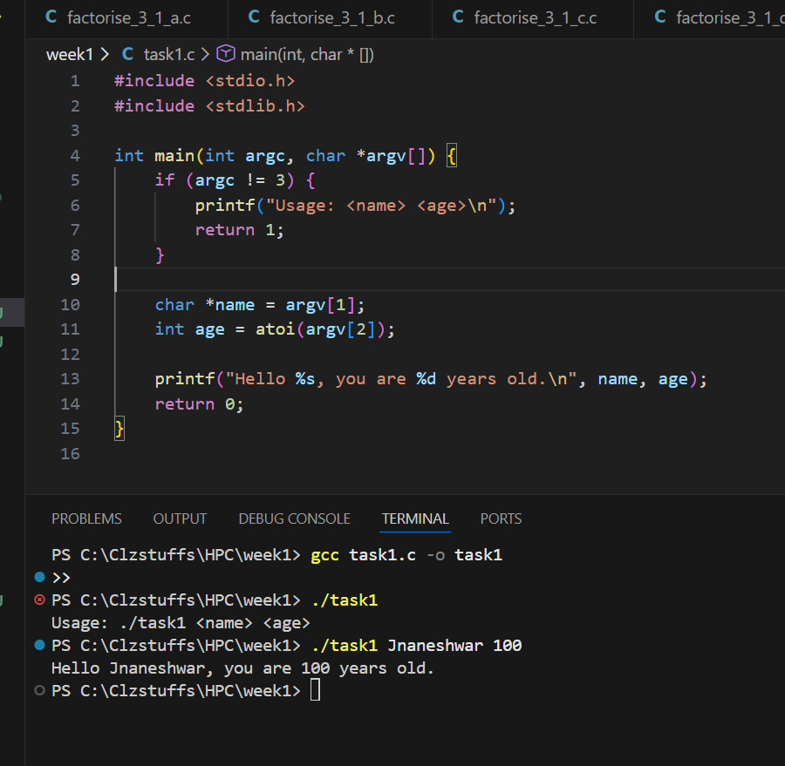
2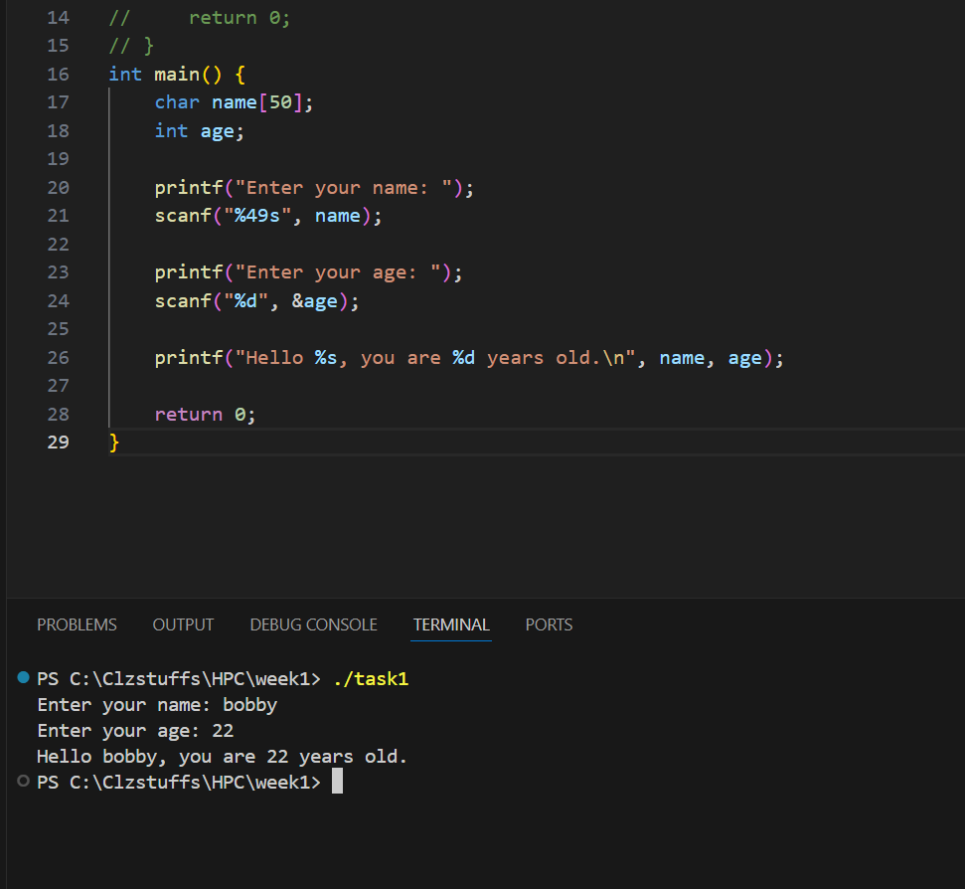
3. 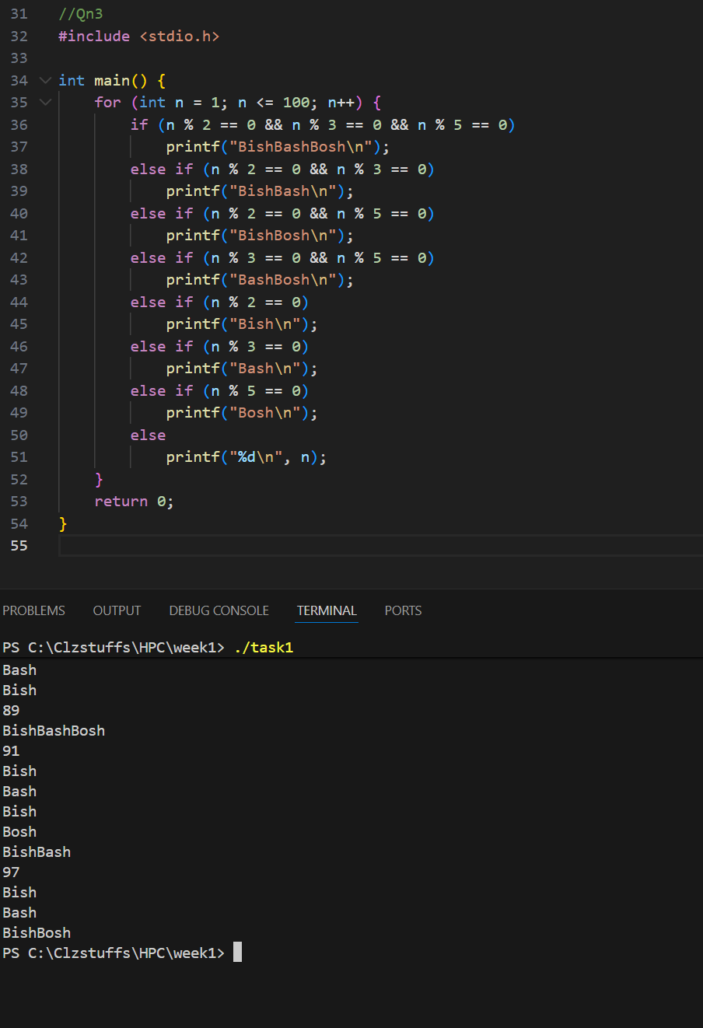
4. 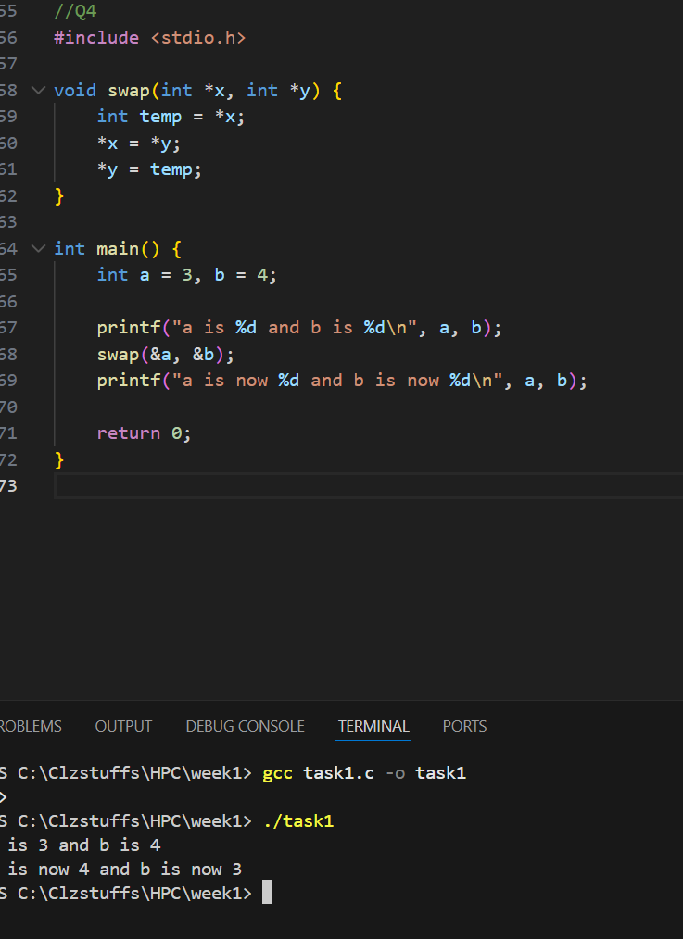
5. 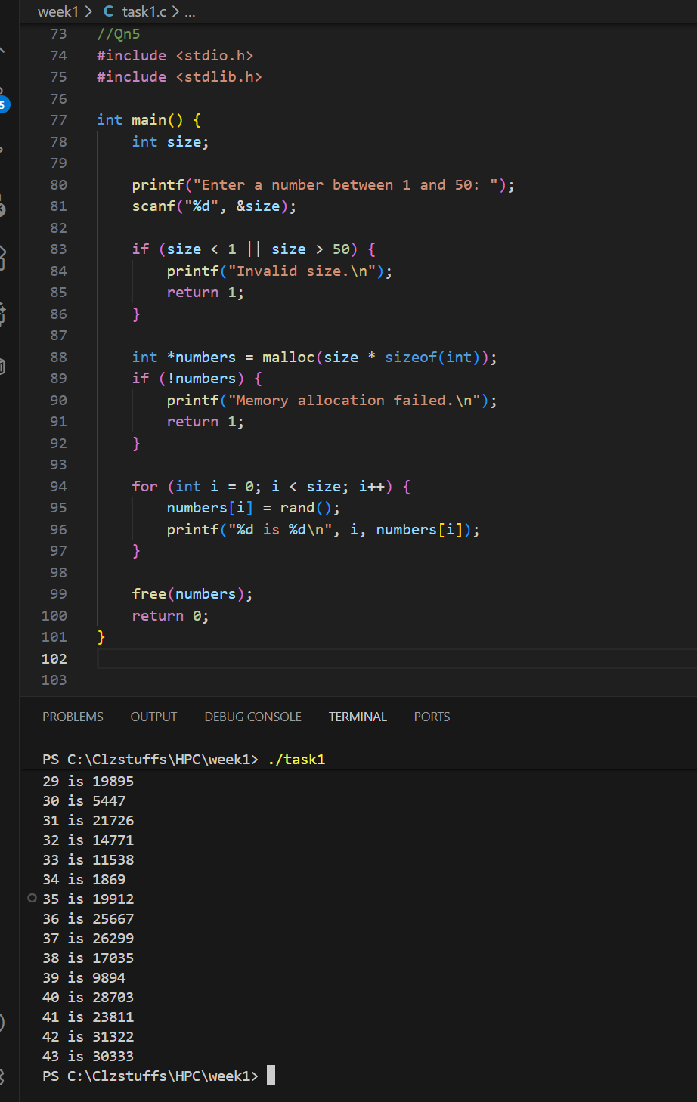
6.
